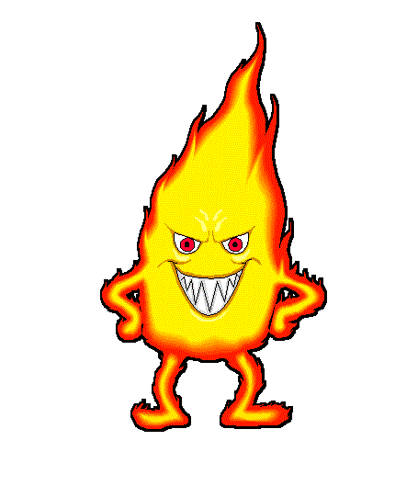
Name: ____________________________ #___
I Survived The Great Chicago Fire, 1871
Novel Activities
Part 1: Making Inferences
Page | Evidence | Inference Made
4 | The train chugged and swayed and jerked its way toward Chicago
8 | Mr. Morrow and Mama’s soft laughter upstairs; Mama getting letters from Mr. Morrow every single day.
21, 24 |  | The setting is long ago.
32 |  | Oscar is scared.
75 | Mr. Morrow had stayed behind risking his life to look for Oscar.
87 |  | Mom and Oscar missed each other and love each other so much.
Part 2: Compare/Contrast
Give at least 3 examples of how the city of Chicago is different than the town of Castle. (Hint: Use chapters 3 and 9 to help you.)
Chicago | Castle

Part 3: Cause and Effect
Page | Cause | Effect
3 | A ball of fire and cinders crashed through the window.
5 |  | Oscar feels sick.
23 | It hasn’t rained here in months.
Page | Cause | Effect
47 |  | The kids will be safe in the Palmer House hotel during the fire.
59 | Bruno and Jennie used to go with their mom to deliver cakes and cookies.
66 |  | Otis reached into his jacket and pulled out a huge knife.
84 | Paint Warehouse explosion

Part 4: Figurative Language
Page | Figurative Language | Type (simile, metaphor, personification, idiom) | What is the author trying to show through this example of figurative language?
3 | The flames clawed at him, seared him, threw him to the ground.
Page | Figurative Language | Type (simile, metaphor, personification, idiom) | What is the author trying to show through this example of figurative language?
5 | He slouched down in his seat and glued his eyes to his dusty boots.
30 | Before he knew what was happening, they (burning embers) were all around him, attacking like a swarm of fiery bees.
34 | The ground was a sea of ash.
54 | With every gust of wind, the flames rose higher, twisting and dancing in the sky as though teasing the firefighters.
71 | It (fire) raced across the prairie, faster than a horse could gallop.
78 | With so many factories lining the shores, Oscar knew the water must be a filthy witch’s brew.

Part 5: Context Clues – Use the context of the sentence to tell what the underlined word means. Then explain the clues you used to help figure out its meaning. Finally tell the part of speech (noun, verb, adjective, or adverb).
- Page 16- The bullet hit Papa in the chest. It should have torn a hole right through Papa’s heart. But it ricocheted off his badge instead, leaving a big dent smack-dab in the center.

Ricocheted means __________________________________
The clues I used to figure out the meaning were: ___________________________________________________
Part of speech is a: _______________

- Page 23 – The entire town could have been lost. But just flames were lapping at the edges of Main Street, a big rainstorm blew in and doused the fire.

Doused means __________________________________
The clues I used to figure out the meaning were: ___________________________________________________

Part of speech is a: _______________

- Page 34 – Oscar had learned for himself during the Castle fire how a fire could grow and grow, how it could become like a ferocious beast that would devour everything in its path.

Ferocious means __________________________________
The clues I used to figure out the meaning were: ___________________________________________________

Part of speech is a: _______________

Devour means __________________________________
The clues I used to figure out the meaning were: ___________________________________________________

Part of speech is a: _______________

- Page 40 – He teetered and almost fell down the stairs. But somehow he managed to regain his balance.

Teetered means __________________________________
The clues I used to figure out the meaning were: ___________________________________________________

Part of speech is a: _______________

- Page 44- Jennie kneeled down and gently peeled Bruno away from Oscar. “Let’s give him a little room,” Jennie said.

Peeled means __________________________________
The clues I used to figure out the meaning were: ___________________________________________________

Part of speech is a: _______________

- Page 57 – Like a herd of cattle startled by a clap of thunder, the crowd erupted into a stampede. Oscar, Jennie, and Bruno were caught right in the middle. Elbows jabbed them, boots mashed Oscar’s feet.

Stampede means __________________________________
The clues I used to figure out the meaning were: ___________________________________________________
Part of speech is a:_____________

