Name: ___________________________
Novel Activities – I Survived the Hindenburg Disaster, 1937

Part 1 - Visualization – In chapter 5, Hugo’s family is boarding the Hindenburg. Draw an illustration of 2 of the areas aboard the zeppelin. Label each area you are drawing.

Part 2 - Figurative Language- State what is being compared in each simile below. Then explain what is meant by it.
Page | Simile | What 2 things are being compared? | What does the simile show us:
10 | ….men looked like flies buzzing around an elephant.
19 | It (Hindenburg) loomed over them like a silver mountain.
68 | The patter of rain sounded like a million rocks pounding against the zeppelin.
Part 3 - Animal Scavenger Hunt (Locating Information)- Match the character in the book with the animal that describes him/her. Include the page number where you got your answer. Use pages 23, 29, 30, 31, 32, and 89 to help.

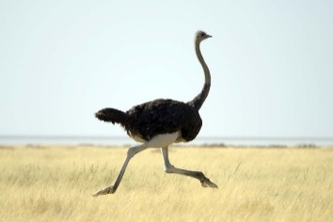ostrich cheetah
gazelle 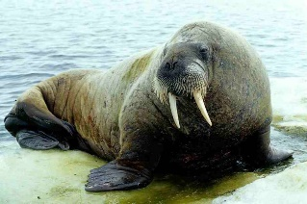 walrus cobra baboon fox

Marty – page ________ Animal comparison: __________________
Miss Crowther – page ______ Animal comparison: __________________
Mr. Lenz – page ________ Animal comparison: __________________
Hugo – page ___________ Animal comparison: ____________________
Colonel Kohl – page _______ Animal comparison: __________________
Mr. Merrick – page ________ Animal comparison: __________________
Gertie – page ________ Animal comparison: __________________

Part 4 - Making Inferences – Readers are not always told everything by an author. Sometimes they have to read between the lines and make inferences. They use the evidence (text) along with their schema (background knowledge) to figure things out. Fill in the boxes below using the assigned pages.
Page | Evidence | Inference – I infer that…..
24 | Like a feather lifted by the breeze, the great airship rose silently off the earth.
26 | Hugo helped himself to another warm roll, which was as fluffy as the clouds out the window. He’d already eaten four, but nobody seemed to mind.
34 |  | People are nervous with Colonel Kohl around.
54 |  | Hugo really loves her sister, Gertie.
Page | Evidence | Inference – I infer that…..
71 | Hugo spotted an enormous building – the Hindenburg’s hangar. Beyond it was a big open field where the landing crew was already waiting. There must have been at least two hundred men.
81 | Hugo could see that Colonel Kohl wouldn’t ever be getting up again.
88 |  | Hugo is really happy to see Gertie.

Part 5 - Genre – I Survived The Hindenburg Disaster, 1937 is a great example of historical fiction. Historical fiction bases the fictional story around a real life event from history.
Fictional piece of the story: ____________________________________________________________________________________________________________________________Historical part of the story: ______________________________________________________________

Part 6- Story Map
Characters:

Setting:

Problem:

Solution:

Part 7 - Going Beyond this Text
Extra Credit –
Compare/Contrast: Another one of the I Survived books by Lauren Tarshis is about traveling on the massive boat, the Titanic.
After reading both books, fill in the chart below with at least 2 ways the Titanic ship was alike and different from the Hindenburg.
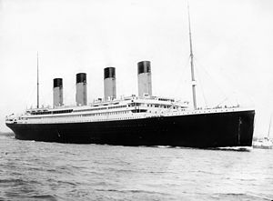  Titanic | Both | Hindenburg  