Name: ______________________________
I Survived The Attack of the Grizzlies, 1967

Part 1: Figurative Language
Directions: Tell what type of figurative language is displayed below in the chart.
Choices: simile, onomatopoeia, idiom, personification
Page | Example | Type
3 | The spindly tree shook, as though it was as terrified as Mel.
14 | Each quill was like a small arrow.
25 | Her eyes were glued to the grizzly’s paw.
27 | Bam! Bam! Bam! Crash!
27 | The wood of the door groaned and cracked.
43 | “That bear….it was like a monster.” Mel said.
59 | There were even straw wrappers floating in the air, like ghostly little birds.

Part 2: Compare and Contrast
Directions: Cut out and glue the boxes into the venn diagram below for the black bear and grizzly bear.
Have a hump between their shoulders
Can be black, brown, and blond

Short claws
Long claws
No prominent shoulder hump
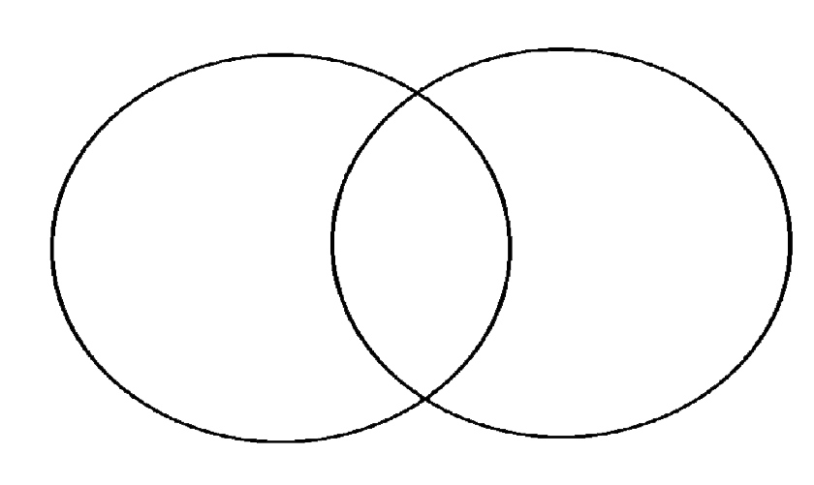

GRIZZLY BEAR
BLACK BEAR

Part 3: Sequencing
Directions: Number the following events in the correct order. Use the ordinal numbers from 1st to 9th.
Ordinal Number | Event
 | Aunt Cassie comes. Mel and Aunt Cassie go talk to the ranger. They don’t get much help.
 | Two girls get killed.
 | Mel puts out the campfire. A grizzly follows her to the cabin and attacks the door.
 | Mel learns grizzlies come and eat food from the trash area, and people wait to watch them devour it.
 | Dad comes to the cabin a year later. Changes are being made to help Glacier and other national parks.
 | A man named Stephen Weiss tells Aunt Cassie and Mel about how the trash in the park is attracting the grizzlies. He invites them to hike up and see what is going on at the Granite Park Chalet.
 | Mel is attacked by the grizzly while she hides up in a tree. A porcupine comes to the rescue and scares the bear away.
 | Mel and Kevin go to stay at the cabin in Glacier National Park with their Pops.
 | They eat dinner, and then they have a sing-along. Mel runs out of the building.

Part 4: Letter Writing
Write a letter to National Geographic telling of the problems that are happening up at the Granite Park Chalet. State at least 3 things that upset Mel, Aunt Cassie, and Steve. Use the friendly letter format.
__________________

_________________________,

_____________________________________________________

_____________________________________________________

_______________________

_______________________
Part 5: Recalling Information
List 3 examples from the story of times that Mel is reminded of her mom. (Hint: Use chapter 15 to help you.)

- _______________________________________________________

- _________________________________________________________

- _________________________________________________________

After the deaths of the 2 girls, Glacier and other national parks in America started to be transformed. List 3 ways the parks have been transformed. (Hint: Use chapter 20 to help you.)
- _______________________________________________________

- _______________________________________________________

- _______________________________________________________

Part 6: Inferences
What do these examples from the book show us?
- Page 16 – Pops chuckled. “Enough stories for tonight,” he said. He stood up slowly. His stiff knees cracked.

____________________________________________________

- Page 17 – When the fire was good and out, Mel stood for a few minutes, leaning on the shovel. She stared up at the stars. She could see a million more here than back home in Milwaukee.
__________________________________________________________
- Page 22 - The cabin was only a few yards away. But it seemed like hours before she got there. And then Mel couldn’t stop herself. She turned and practically flew up the rickety wooden stairs to the porch. She burst into the cabin and slammed the heavy wooden door shut behind her.
___________________________________________________________

- Page 32 - She always made them feel lucky when they saw something wild. To her, a shiny green beetle was more beautiful than a diamond ring. Every spider’s web was a work of art.
___________________________________________________________

Part 7: Cause and Effect
Cause | Effect
 | Mel’s mom dies. (chapter 2)
The grizzly followed Mel to the cabin. (chapter 10)

 | Mel, Kevin, Pops, and Aunt Cassie leave the cabin at Glacier National Park. (chapter 19)

