Name: _____________________ #____
Book Activities – I Survived The Nazi Invasion, 1944
Part 1: Use the map below to identify the country of Poland.
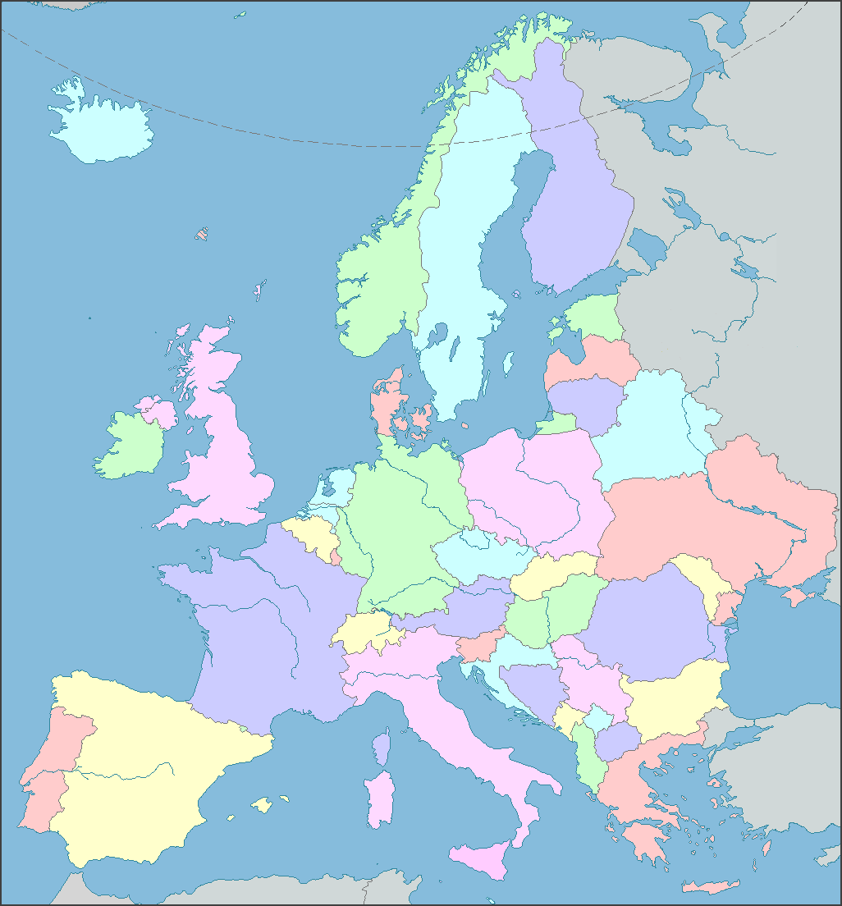

Part 2: In the story, the main character, Max, deals with lots of different emotions at different points in the book. Fill in the chart below with at least one example to show each of these different emotions. Use the provided page numbers to help you.
Emotion: | Page Number(s): | Example(s) From Book:
Angry/mad | Pgs. 5, 17, 70
Scared | Pgs. 12, 29, 49, 51, 59
Frustrated | Pg. 8
Excited | Pg. 26

Part 3: Max and his sister, Zena, have a very close brother-sister relationship. Go back in the story and find at least 2 examples that show this special bond between one another.
1.

2.

Part 4: Figurative Language – Use the page numbers and the book to find examples of figurative language (similes, metaphors, personification, hyperboles, and idioms).
Page Number | Type of Figurative Language | Example
6 | simile
9 | personification
9-10 | simile
12 | simile
13 | simile
17 | simile
25 | Personification
35 | metaphor
39 | Hyperbole
41 | simile
42 | simile
46 | simile
50 | idiom
53 | simile
64 | idiom
77 | simile

Part 5: Synonyms: Write a synonym for the bold-faced underlined word on each provided line. Then write the part of speech for your word (noun, verb, adjective, adverb).
- Sparks showered down like burning snowflakes. (pg. 2) __________________ Part of speech: ___________

- Before she could change her mind, Max was on his stomach, slithering under the fence. (pg. 10) _________________ Part of speech: ___________

- Max’s head throbbed from where the soldier had smacked him. (pg. 12) ________________ Part of speech: ___________
- But the soldier whirled around, his piglike eyes squinting into the thicket on the side of the road. (pg. 15) __________________ Part of speech: ___________

- Max peered through the hay. (pg. 29) _____________________ Part of speech: ___________
Part 6: Making Inferences
- When Zena popped the berries into her mouth (pg. 10), the author says she had the biggest smile Max had seen in weeks. Why do you think she was smiling so much? __________________________________

- The author says, “It was late at night, and Hannah had come to their house. Max was almost asleep when he heard her voice. He’d almost leaped out of bed to see her.” What do these words show us about the relationship between Max and his Aunt Hannah? ______________________________

- Why do you think when Max saw the farmer, his first reaction was to stand up, get between the farmer and Zena, and get ready for a fight? _________________________________________________________
Part 7: Sequencing - Put the following events from chapter 4 in order.
____ The rifle butt hit a rock.

____ The kids escaped by running toward the wheat field.

____ The rifle fired.

____ Max threw himself against the man.

____ The rifle sailed through the air.

____The bullet hit the soldier in the leg.
Part 8: Making Connections
In chapter 10, Max is trapped by the tree that has fallen on him. While in the ditch, he has to figure out how to get out. Describe a time when you had something that was hard for you. What was your plan to overcome your problem?

_________________________________________________________

_________________________________________________________

